Style Guidelines for Final Year Project ReportsAdvanced Learning Management System

Final Year Project Proposal

Session 2024-2025

A project submitted in partial fulfilment of the requirements

for the degree

of

Bachelor of Science in Computer Science



Department of Computer Science

Namal University Mianwali

09 October 2024

**Project Registration**

|  |  |  |  |  |  |  |  |
| --- | --- | --- | --- | --- | --- | --- | --- |
| Project ID (for office use) | | |  | | | | |
| Type of project | | | [ ] Traditional [✔ ] Industrial [ ] Continuing | | | | |
| Nature of project | | | [✔] **D**evelopment [ ] **R**esearch [ ] **R**&**D** | | | | |
| Area of specialisation | | | Full Stack Web Development | | | | |
| **Project Group Members** | | | | | | | |
| Sr.# | Reg. # | Student Name | | CGPA | Email ID | Phone # | Signature |
| (i) | NIM-BSCS-2021-24 | Muhammad Bilal | | 2.98 | mbilal2021@namal.edu.pk | 03085848106 |  |
| (ii) | NIM-BSCS-2021-33 | Ali Shoaib | | 3.02 | ali.shoaib2021@namal.edu.pk | 03041892084 |  |
| **Declaration:** FYP group members have cleared all prerequisites courses (mentioned below) for FYP-I as per their degree requirements.  (CS-131 Object Oriented Programming, CS-260 Software Engineering Concepts, CS-250 Database Systems, ENG-111 Technical Writing and Communication) | | | | | | | |

**Plagiarism Free Certificate**

This is to certify that, I am ________________________ S/D/o _______________________, group member of FYP under registration no _____________________ at Computer Science Department, Namal University. I declare that my FYP proposal is checked by my supervisor and the similarity index is ________% that is less than 20%, an acceptable limit by HEC. Report is attached herewith as Appendix A.

Date: ____________

Name of Group Member 1: ________________________ Signature: _____________

Name of Group Member 2: ________________________ Signature: _____________

Name of Supervisor: _____________________

Signature: _____________________

Contents

Table of Figures 4

1 Introduction 5

2 Related work 6

3 Project Rationale 6

3.1 Aims and Objectives 6

3.2 Scope of the Project 7

3.2.1 Project Goals: 7

3.2.2 Deliverables: 7

3.3 Success Criterion 8

3.4 Proposed Methodology and Architecture 8

3.4.1 Activity Diagram: 9

4 Individual Tasks 10

5 Tools and Technologies 10

6 Gantt Chart 11

7 References 11

# Table of Figures

Figure 1: Activity Diagram 8

Figure 2:Gantt Chart 10

**Project Abstract**

Innovative web application called the Advanced Learning Management System (ALMS) is intended to revolutionize the way educational establishments oversee and conduct instruction. By providing a strong platform for educators, administrators, and students, its main objective is to improve the teaching and learning process. The ALMS simplifies course management and makes it simple for educators to produce, arrange, and distribute instructional materials because to its intuitive interface and emphasis on accessibility. The entire learning process is improved by the system's content management tools, which make it easy to post and share educational resources.

Numerous jobs are made easier by the automatic capabilities in the ALMS. Teachers can design quizzes by entering options and questions in the quiz and assignment management system, which is a crucial function. Teachers' grading effort is reduced because the system allows for automated grading of multiple-choice questions (MCQs). Assignments can be made by teachers as well.

Enhance the platform even more by adding video-based learning and real-time assessments to reinforce topics through self-paced learning. By using an AI-optimized schedule generation method, ALMS also handles scheduling, guaranteeing institutions have conflict-free scheduling. With the help of its progress monitoring tools, teachers and students may keep an eye on student performance and gain insights for ongoing development.

Comprehensive user management and attendance monitoring tools let administrators better manage student enrollment and attendance trends. With features for real-time communication, the system encourages teamwork and improves communication between teachers and students. Through the integration of contemporary features with conventional teaching methods, the ALMS seeks to enhance student learning outcomes, optimize the educational process, and produce a more engaging learning environment. This all-in-one solution caters to the diverse needs of universities, offering both flexibility and efficiency.

# Introduction

With the introduction of artificial intelligence (AI), machine learning, and the growing usage of digital platforms like YouTube for instructional reasons, the field of education is changing quickly. The lack of interactive features and data-driven insights in traditional learning management systems (LMS) makes them increasingly unable to keep up with these changes in teaching and learning. In response, our Advanced Learning Management System (ALMS) uses cutting-edge technologies to simplify administrative work and enhance the learning process in an effort to revolutionize the university classroom.

In order to save teachers time while maintaining a high standard of instruction, our ALMS has features that support automated multiple-choice question (MCQ) grading, real-time course management, and self-paced learning using YouTube videos with embedded evaluations. Furthermore, physical attendance records and teamwork instruments guarantee that human supervision is still essential to classroom administration. Instructors have the ability to make assignments and quizzes; the MCQ system evaluates the MCQs automatically, freeing the teacher up to concentrate on marking textual work. Modern colleges have logistical and pedagogical needs, and this balanced approach to automation and manual controls meets those needs while maintaining an efficient and productive learning environment.

# Related work

LMS platforms are not a new idea; what is newer is the emphasis on improving particular parts of assessment and course management by automating processes and incorporating contemporary teaching strategies. For instance, Google Classroom [1] launched interactive video-based learning assignments. These assignments consist of questions that are embedded into YouTube movies and provide real-time performance tracking and feedback. Our solution builds on this concept by integrating interactive video-based quizzes with automated grading for multiple-choice questions (MCQs), offering educators the capacity to assess students' mastery of video content in real-time.

While many course administration capabilities are available in existing systems like as Moodle [2] and Blackboard [3], they usually lack current automation for grading multiple-choice questions and providing real-time progress insights. In contrast to these platforms, our ALMS allows educators to build assignments and quizzes, guaranteeing academic rigor and flexibility, and it also includes auto-grading specifically for MCQ-based quizzes. Furthermore, our method retains the human aspect in qualitative assessments by having teachers score written tasks.

We compare our ALMS with current systems in order to fill in the gaps left by traditional LMS platforms. We do this by providing a combination of essential manual controls for course creation, assignment management, and student progress tracking with cutting-edge automation features like MCQ auto-grading and YouTube video-based assessments.

# Project Rationale

The increasing demand on educational institutions to implement more effective, technologically advanced solutions is the driving force behind the Advanced Learning Management System (ALMS) initiative. The need for tools that can automate administrative processes, track student achievement, and simplify course management is growing as hybrid and digital learning models become more prevalent. Modern teaching approaches are limited by the inadequacies of traditional learning management systems when it comes to combining AI-powered capabilities, real-time collaboration tools, and performance tracking.

## Aims and Objectives

Our project will provide an efficient, user-friendly learning management system (LMS) that facilitates the management of schedules, assessments, and instructional materials in order to close these gaps. Additionally, it will allow multiple-choice questions to be graded automatically (MCQs). By stressing manual control for teachers in areas like quiz production and attendance, the system combines automation with conventional oversight in education. The following objectives are particularly the focus of the initiative:

* **Course Management:** With real-time content management features, instructors may plan, prepare, and teach courses.
* **Use self-paced learning to reinforce concepts:** Include interactive YouTube videos with MCQs that may be automatically graded, as well as performance insights.
* **Automated Timetable Generation:** Use AI-driven scheduling to make timetables free of conflicts and use resources as efficiently as possible.
* **Progress tracking:** Give instructors and students access to real-time performance data.
* **User Management:** Simplify course registration and administration by enabling role-based access for educators, administrators, and students.
* **Collaboration Tools:** Offer instantaneous communication tools, like message boards and chat rooms.
* **Manual Attendance System:** Provide teachers with the ability to track attendance and produce reports on it.
* **Quiz & Assignment Creation:** Give teachers the ability to make quizzes with written responses that are automatically graded and MCQ-based.

## Scope of the Project

Part of the ALMS project's objective includes developing a comprehensive web-based platform to enhance the educational experiences of teachers and students. Course administration, automatic multiple-choice question grading, and interactive video assignments for self-paced learning are planned features of the website. In addition, the system will include teamwork-enhancing communication capabilities, real-time progress tracking, and the capacity to make schedules in order to manage scheduling issues. Role-based access will ensure secure user management while manual attendance tracking will give educators control over student engagement.

### **Project Goals:**

The project's objective is to develop a robust and adaptable learning management system (LMS) in order to enhance instructional strategies and learning results. It will have efficient processes for scheduling and assigning resources in place to lessen conflicts. It will also facilitate easy communication and teamwork among teachers, administrators, and students, fostering an engaging learning environment. To ensure participant accountability, robust procedures for tracking and recording attendance will also be put in place.

### **Deliverables:**

* A web-based platform that is fully operational and available to educators, administrators, and students.
* MCQ-based quiz auto grading in addition to instructors' manual quiz authoring.   
  YouTube video assignments that are interactive and have automatic MCQ grading.
* A mechanism for creating timetables with AI that resolves conflicts.
* Access control for teachers, administrators, and students depending on roles.   
  Instructors keeping track of and reporting attendance by hand.
* Tools for real-time collaboration, such as discussion boards and chat.

## Success Criterion

* The success of the ALMS project will be evaluated based on the following criteria:
* **Functionality**: The system must manage courses, quizzes, assignments, track progress, and facilitate attendance tracking effectively.
* **User Satisfaction**: The platform should provide a user-friendly and engaging experience, as measured by user feedback.
* **System Performance**: The system should handle multiple concurrent users, ensuring fast response times for real-time collaboration and scheduling.
* **Supervisor Approval**: The project must meet all objectives and expectations set by the Stakeholders.
* **Client Satisfaction**: If applicable, client feedback will determine the system's ability to address specific needs.
* **On-time Completion**: The project must meet all milestones and deliverables within the designated timeline while ensuring quality and minimizing delays.

By meeting these criteria, the ALMS aims to provide a modern LMS solution that enhances both teaching and learning experiences, combining automation with essential manual controls.

## Proposed Methodology and Architecture

The ALMS will be developed using an Agile methodology, ensuring iterative development with continuous feedback from users and stakeholders. This flexible approach will allow for the incorporation of new requirements as the project evolves.

### **Activity Diagram:**

Figure 1: Activity Diagram

# Individual Tasks

|  |  |  |
| --- | --- | --- |
| **Team Member** | **Activity** | **Tentative Date** |
| Ali Shoaib | User Management | 30-10-2024 to 18-11-2024 |
| Muhammad Bilal | Course Management | 30-10-2024 to 18-11-2024 |
| Ali Shoaib | Quiz & Assignment creation | 21-11-2024 to 10-12-2024 |
| Muhammad Bilal | Progress Tracking | 21-11-2024 to 10-12-2024 |
| Ali Shoaib | Collaboration Tools | 13-12-2024 to 01-01-2025 |
| Muhammad Bilal | Attendance System | 13-12-2024 to 01-01-2025 |
| Ali Shoaib | Reinforce concepts with self-paced learning | 03-01-2025 to 20-02-2025 |
| Muhammad Bilal | Automated Timetable Creation | 03-01-2025 to 20-02-2025 |

# Tools and Technologies

* **Frontend**: React, HTML/CSS, tailwind CSS
* **Backend**: Node.js, Express (with optional Django integration)
* **Database**: MongoDB, SQL Server
* **Version Control:** Git/GitHub
* **Team Communication:** Slack

# Gantt Chart

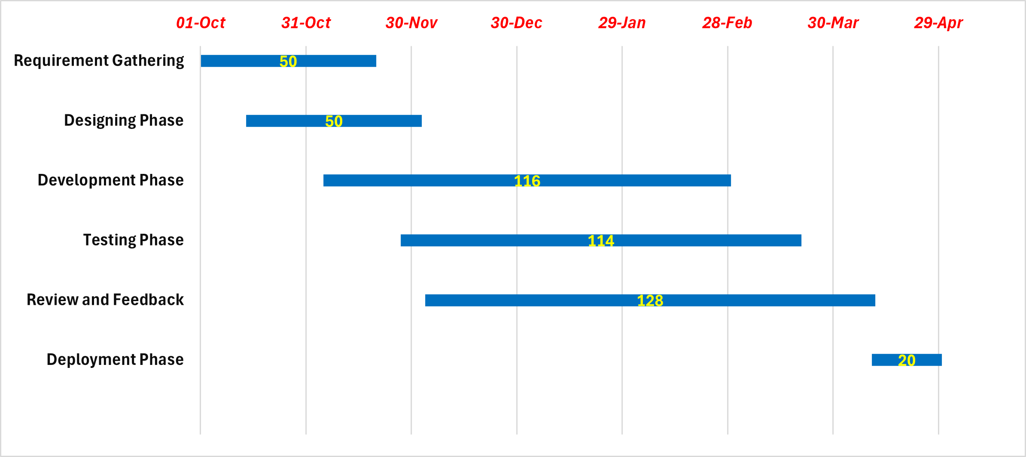

Figure 2:Gantt Chart

# References

|  |  |
| --- | --- |
| [1] | “Gooogle Classroom,” [Online]. Available: https://edu.google.com/workspace-for-education/classroom/. |
| [2] | “Moodle,” [Online]. Available: https://moodle.org/. |
| [3] | “Blackboard,” [Online]. Available: https://help.blackboard.com/Learn. |